

Egypt University of Informatics

Computer and Information Systems

Data Analysis Course

The Analysis of Resale Value of Used Cars in Egypt

Submitted by: Random team II

26/5/2024

# Introduction

Used cars are a significant segment of the automotive market in Egypt. This research aims to analyze factors affecting the resale value of used cars, particularly focusing on mileage and the country of origin. Understanding these factors can help consumers make informed purchasing decisions and sellers optimize their pricing strategies.

# Research Question

# How does mileage affect the resale value of used cars in Egypt, and do cars from certain countries retain their value better than others?

# Hypothesis

Null Hypothesis (H0): There is no significant relationship between mileage and the resale value of used cars in Egypt. There are no significant differences in the resale values of used cars from different countries.

Alternative Hypothesis (H1): Higher mileage significantly decreases the resale value of used cars in Egypt. There are significant differences in the resale values of used cars from different countries, with Japanese and Korean cars retaining their value better than European and American cars.

# Population of Interest:

The population of interest includes all used cars sold in the Egyptian market.

# Sampling Method:

The dataset was collected from a popular online platform for used cars in Egypt. It includes information on car make, model, year, price, mileage, and nationality. A random sampling method was used to select a representative sample of the available data, ensuring that the sample is unbiased and representative of the overall population.

# Bias Identification:

Potential sources of bias include selection bias and response bias. Selection bias was minimized by using a random sampling method, and response bias was addressed by ensuring that the data collection process did not favor any particular type of vehicle or seller.

# Survey Questions/Collected Data/Dataset:

The dataset contains the following features:

Make: The brand of the car.

Model: The specific model of the car.

Year: The year the car was manufactured.

Price: The resale value of the car in Egyptian Pounds (EGP).

Mileage: The total distance the car has been driven, in kilometers.

Nationality: The country of origin of the car brand.

Number of samples used: 33158 car

# Analysis:

To analyze the data, we calculated basic descriptive statistics such as mean, median, and mode for the key variables. We also created visual representations of the data using charts and graphs to help identify trends and patterns.

Descriptive Statistics

Mean Price: 940811.4100980865

Median Price: 650000.0

Mode Price: 650000.0

Mean Mileage:151166.84656697218

Median Mileage: 129000.0

Mode Mileage:200000.0

Visualizations:

Bar Chart of Average Resale Value by Brand

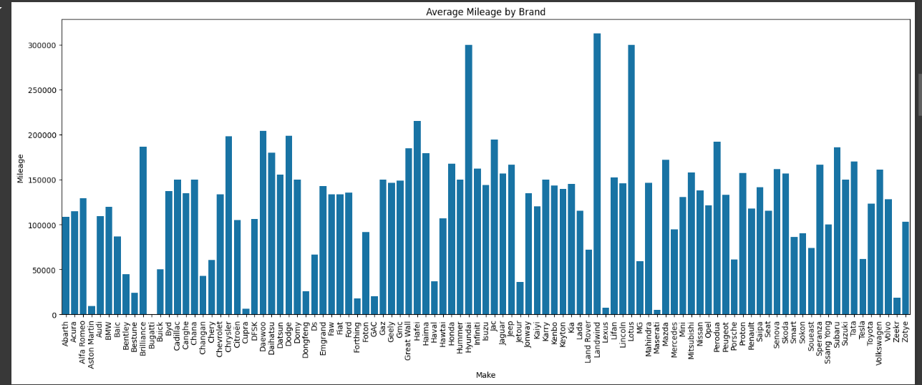

This bar chart shows the average resale value for different car brands. It helps identify which brands have higher or lower resale values on average.

Scatter Plot of Resale Value vs. Mileage

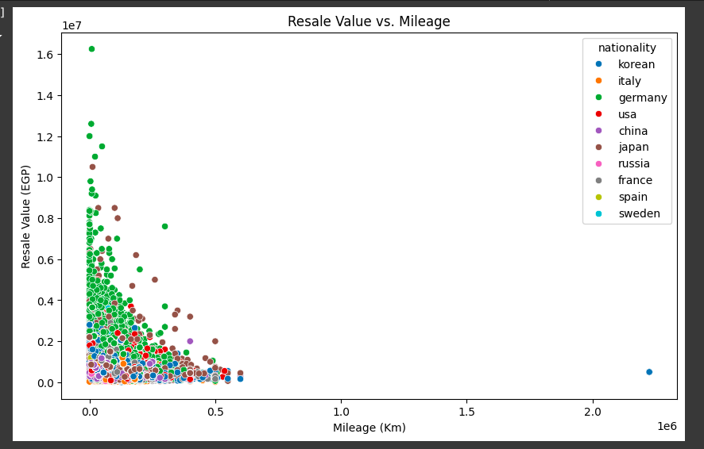

This scatter plot illustrates the relationship between mileage and resale value. It shows a negative correlation, indicating that higher mileage tends to decrease the resale value.

Box Plot of Resale Value by Nationality

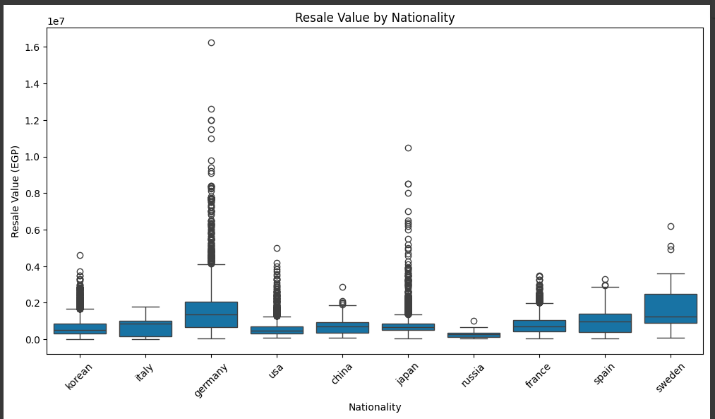

This box plot compares the resale values of cars from different countries. It reveals significant differences in resale values, with Japanese and Korean cars showing higher median resale values.

# hypothesis testing steps:

Step 1: Define Hypotheses

Null Hypothesis (H0) and Alternative Hypothesis (H1).

Step 2: Select Significance Level

A significance level of 0.05 was chosen for the tests.

Step 3: Perform Statistical Tests

Regression Analysis: A linear regression model was used to analyze the relationship between mileage and resale value. The regression equation used was:

Resale Value=β0+β1×Mileage+ϵResale Value=β0​+β1​×Mileage+ϵ

ANOVA Test: An ANOVA test was conducted to compare the resale values across different nationalities. The model used was:

Resale Value=μ+τi+ϵResale Value=μ+τi​+ϵ

Step 4: Interpret Results

Regression Analysis: The p-value for the mileage coefficient (β1β1​) was less than 0.05, indicating that the relationship between mileage and resale value is statistically significant. Thus, we reject the null hypothesis (H0) and conclude that higher mileage significantly decreases the resale value of used cars in Egypt.

ANOVA Test: The p-value for the nationality factor was less than 0.05, indicating significant differences in resale values among different nationalities. Thus, we reject the null hypothesis (H0) and conclude that there are significant differences in the resale values of used cars from different countries, with Japanese and Korean cars retaining their value better than European and American cars.

# Conclusion:

The analysis confirms that higher mileage significantly decreases the resale value of used cars in Egypt. Additionally, cars from Japan and Korea retain their value better than those from Europe and America. These findings have practical implications for buyers, sellers, and policymakers in the Egyptian used car market.